Practical 1: Getting Familiar With SQL*Plus
Learning objectives:
- Login process
- Creating your database
- View the structure of a table
- Insert data into the tables

- The login process

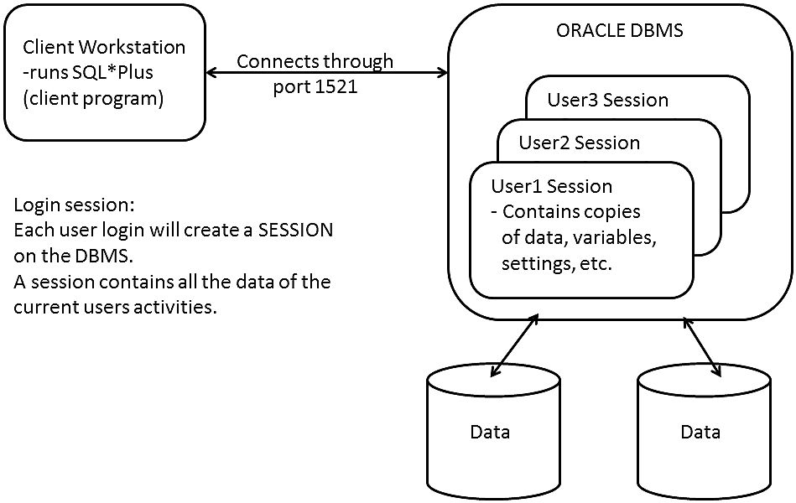

Username:
Password:

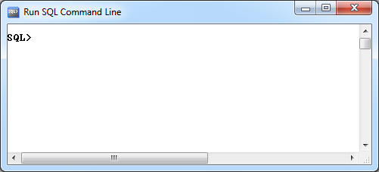

The SQL*Plus program is a client interface for you to connect to the ORACLE DBMS. Your database will be stored in the ORACLE server.
There are many other tools that can connect to the DBMS (e.g. JAVA, C++, SQL Developer, DBeaver, DbVisualizer, SQuirreL SQL, etc).

The practical lessons uses the SQL*Plus client which is a command-line based interface tool.

The SQL*Plus client only allows you to do two things, issue:
- SQL*Plus commands
- SQL statements
(If you want to issue SQL statements , you must first login to the database for the results to be meaningful).

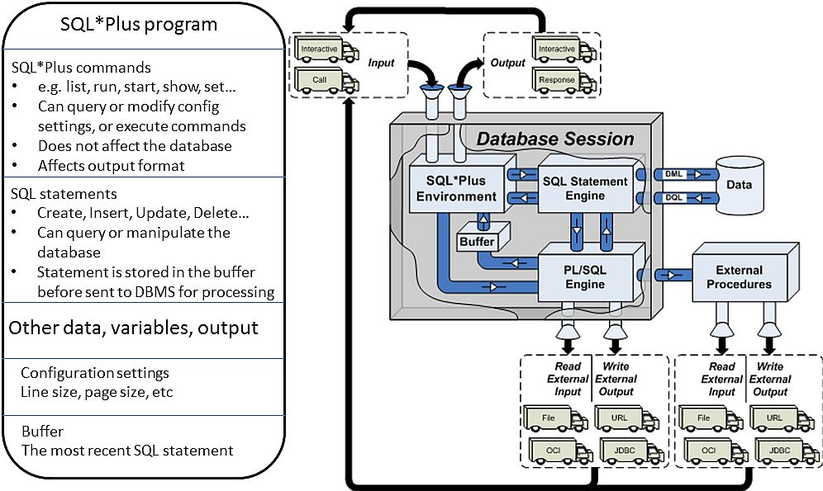

*Learning notes:
(Your own notes of what is important)

Reference: SQLPlus User's Guide and Reference
- Chapter 12 SQL*Plus Command Reference

Before You Start
- Copy the following SQL script to drive C:\
  - 01staff.txt
  - 02category.txt
  - 03menu.txt
  - 04customer.txt
  - 05food_order.txt
  - 06order_list.txt
These scripts contain the SQL statements to create the database that you will use for your practical lessons. (Refer to the OrderProcessingScenario.doc for an explanation)
- Open the 04customer.txt file in notepad to view the commands in this script file.

After connecting to the database
(All SQL and SQL*Plus commands are NOT case sensitive.)

Creating your database
SQL> start c:\04customer.txt
- The SQL*Plus start command will load the 04customer.txt script into the buffer and send it to the DBMS for processing. The result is a database object called a table created, assuming there are no syntax errors.

Viewing the Structure of a Table
Syntax:
DESC[RIBE] table_name;

You need to check that the table you have created is according to your design.
Run this command:
SQL> DESC customer
What is the output?
Ans:

- Continue to execute the scripts to create the other 5 tables of your database.
- Check the structure of the tables created

*Learning notes:
(Your own notes of what is important)

Inserting data
The following are scripts with SQL statements that will populate your database.
  - 01in_staff.txt
  - 02in_category.txt
  - 03in_menu.txt
  - 04in_customer.txt
  - 05in_food_order.txt
  - 06in_order_list.txt

We will use the customer table as an example. First, display the customer table structure:
SQL> DESC customer

Open the script 04in_customer.txt. Execute the first insert statement:

SQL> insert into customer values(1001,'Ali','aBc@tarc.edu.my',null,null,'M');

sample output:
SQL> insert into customer values(1001,'Ali','aBc@tarc.edu.my',null,null,'M');
1 row created.

Check to see the data in the customer table. Use the SQL SELECT statement to query the database:
select *
from customer;

sample output
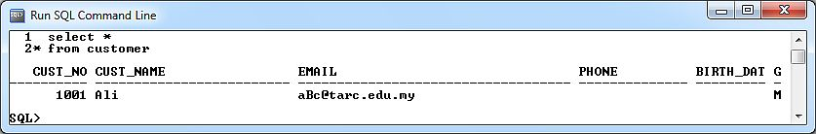
(Your output display may not look exactly the same as above, that’s ok).

Execute the 2nd insert statement:

/* sample output
SQL> insert into customer values(1002,'Abu','abctarc.edu.my',null,null,'M');
insert into customer values(1002,'Abu','abctarc.edu.my',null,null,'M')
*
ERROR at line 1:
ORA-02290: check constraint (xxxxx.CHK_EMAIL) violated
*/
The 2nd insert statement failed; the email address is not according to the correct format, does not have the '@' symbol. Open the 04customer.txt to look at the table design and definition.

Execute the next 2 insert statements and identify the errors.

*Learning notes:

Copy the necessary scripts to drive C:\ and create the rest of the data in the following sequence
  - start c:\01in_staff.txt
  - start c:\02in_category.txt
  - start c:\03in_menu.txt
  - start c:\05in_food_order.txt
  - start c:\06in_order_list.txt

After successful insertion, the total content of you database should look something like this:
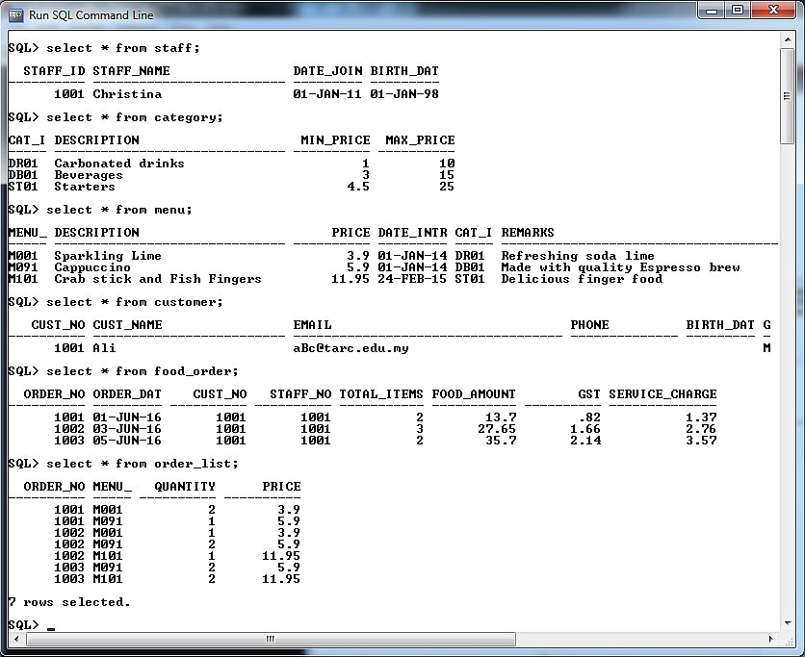

What do you think will be the output for the following statement?
select order_no, order_date,
food_amount, gst, service_charge,
(food_amount+gst+service_charge) as Total_Bill
from food_order;

*Learning notes:

HOMEWORK
Write a brief description of the purpose of each of the following SQL*Plus command.
Command Description
EDIT

SAVE

GET

LIST

RUN

START

SET

SHOW

SPOOL

